22f-3327
BCS 3C
LAB 5
(Total Marks 15)

Task 1: Draw and run following code and write description of execution.
org 0x100
jmp start

multiplicand: db 13
multiplier: db 5
result: db 0

start: mov cl, 4
mov bl, [multiplicand]
mov dl, [multiplier]

checkbit: shr dl, 1
jnc skip
add [result], bl

skip: shl bl, 1
dec cl
jnz checkbit

mov ax, 0x4c00
int 0x21
org 0x100
jmp start

multiplicand: db 13 ; variables to store multiplicand and multiplier
multiplier: db 5
result: db 0

start:
mov cl, 4 ; Load the loop counter (number of bits of multiplier ) into CL
mov bl, [multiplicand] ; Load the multiplicand into BL
mov dl, [multiplier] ; Load the multiplier into DL

checkbit:
shr dl, 1 ; Shift the least significant bit of DL towards right which will put it into the carry flag
jnc skip ; Jump to 'skip' if the carry flag is 0 (no carry from the shift)
add [result], bl ; Add the multiplicand to the result if there's a carry
skip:
shl bl, 1 ; Shift the multiplicand left (effectively multiplying by 2)
dec cl ; Decrement the loop counter
jnz checkbit ; Jump to 'checkbit' if the loop counter is not zero

mov ax, 0x4c00 ; Exit program with code 0
int 0x21
Also fill the following table after execution of each loop in binary form.
Count | Multiplicand | Multiplier | Result
4 | 11010 | 0010 | 1101
3 | 110100 | 0001 | 1101
2 | 1101000 | 0000 | 1000001
1 | 11010000 | 0000 | 1000001

Task 2: Write assembly language code to multiply two-word size numbers:
- Multiply 600* 350
- Use shift right, shift left and rotate carry left operations
org 0x0100

jmp start
multiplicand: dd 600
multiplier: dd 350
result: dd 0
start:
mov cx, 16
mov dx, [multiplier]
check_bit:
shr dx, 1
jnc skip
mov ax, [multiplicand]
add [result], ax
mov ax, [multiplicand+2]
adc [result+2], ax
skip:
shl word [multiplicand], 1
rcl word [multiplicand+2], 1
dec cx
jnz check_bit

mov ax, 0x4c00
int 0x21

600*350 gives 033450 in hexa
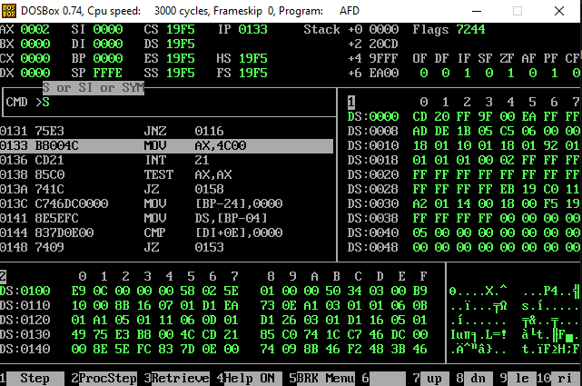

Task 3: Write a program to count the number of 1’s in a word size four variable in single label.
- num: dw 65535, 65535, 39321, 39321
- Use Rotate Left (ROL) Operation
- Count the numbers of 1’s and save it into another variable with its address.
org 0x100
jmp start
num: dw 65535, 65535, 39321, 39321
result : dw 0

start:
mov cx,4
mov bx,num
mov dx,0

count_loop:
mov ax,[bx]
mov si,16

bit_:
shr ax,1
jz _clear
inc dx

_clear:
shr ax,1
dec si
jnz bit_

add bx,2
dec cx
cmp cx,0
jne count_loop

mov [result],dx

mov ax,0x4c00
int 0x21


